Easy worship in Sunday Service

A lot of Church do NOT have the technology to put informations on the screen. So I designed an application that does it. The idea comes from an existing application which name is EasyWorship.

By the way, I did it JUST FOR FUN, so it is NOT perfect.

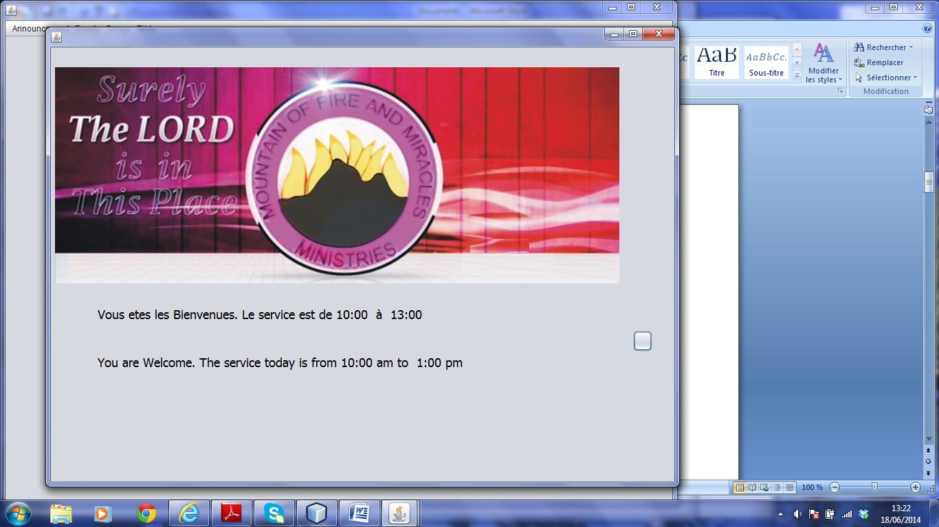

* Bible: It’s the most important part of the Sunday Service.

Let say the pastor is preaching and ask for:

* The book of Judges, Chapter 4 and Verse 6

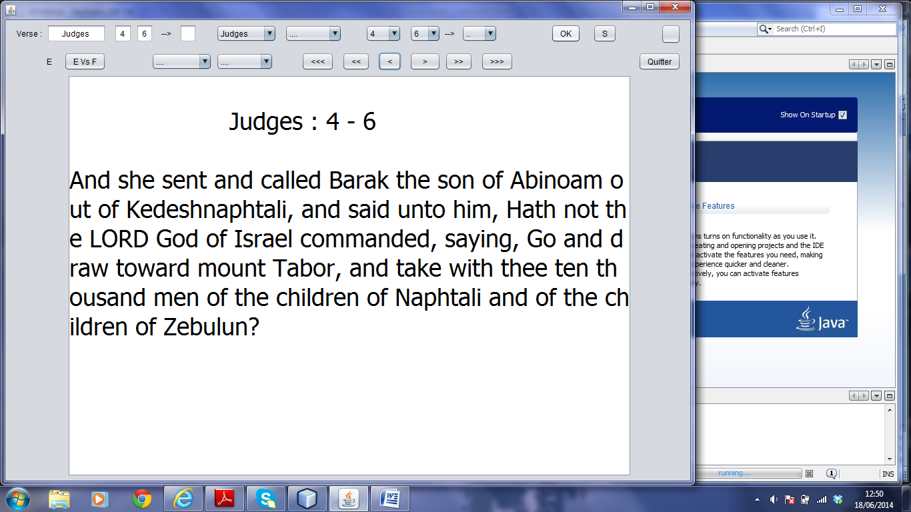

I can go automatiquely to the next verse by pressing on [>] or previous verse [<]

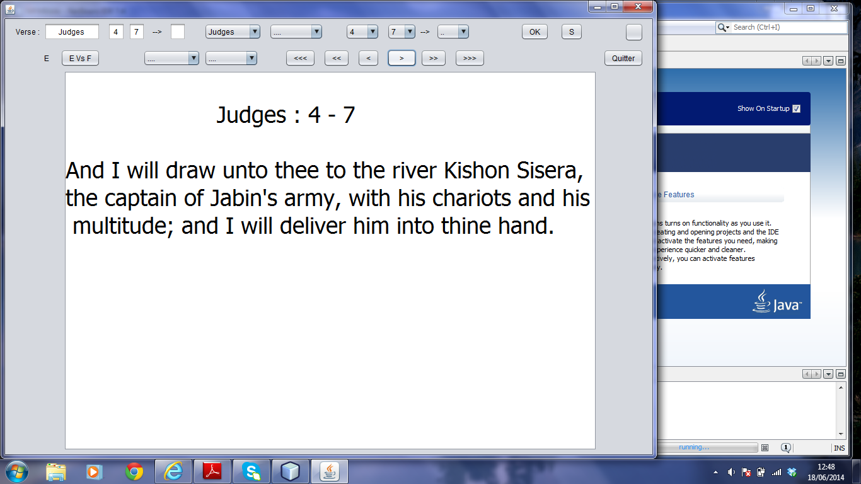

I can go automatiquely to the next chapter by pressing on [>>] or previous chapter [<<]

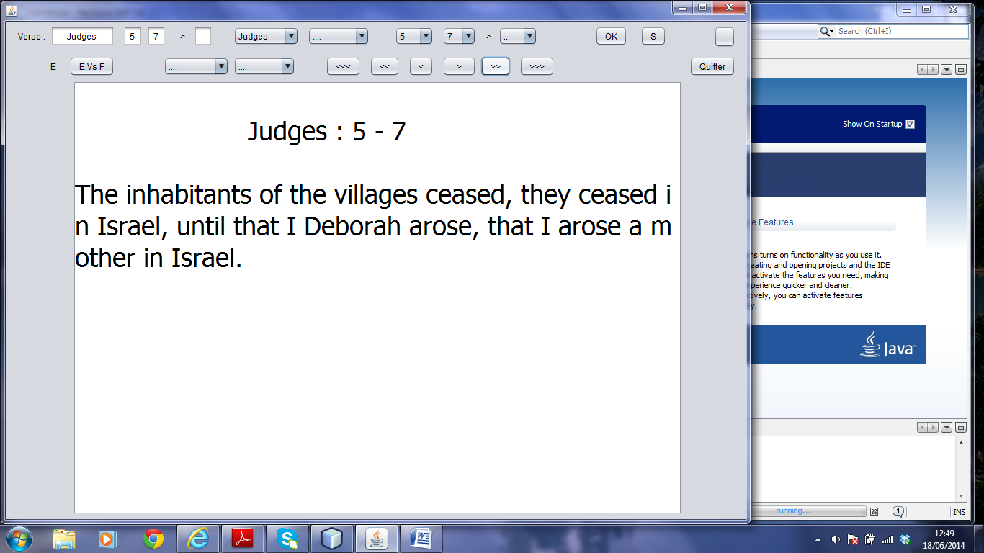

The pastor can ask to read the entire chapter.

* Judges, Chapter 4

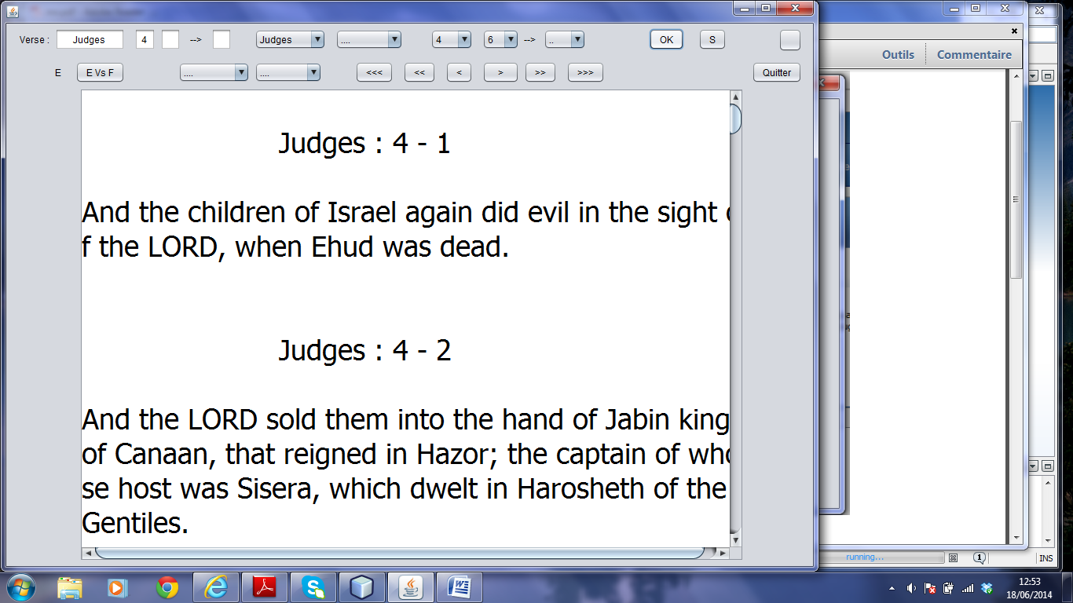

The pastor can ask to read a couple of consecutive verses of a given chapter

* Judges, Chapter 4 and Verse 8 to 11

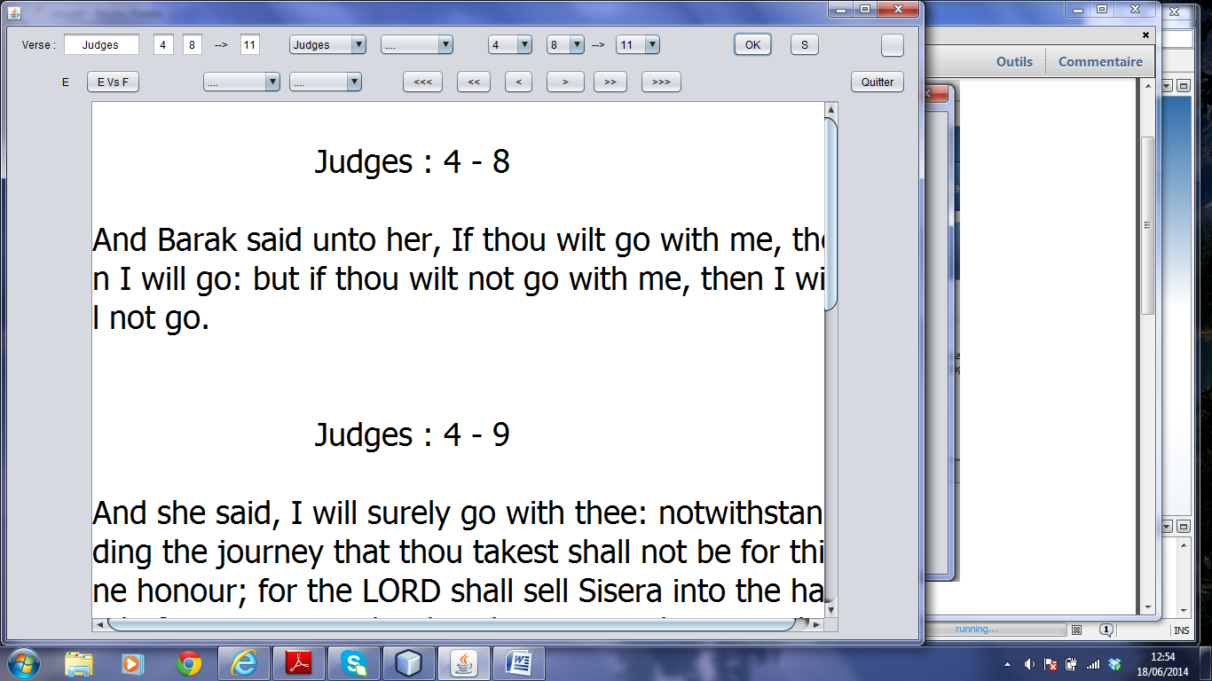

Full screen option

